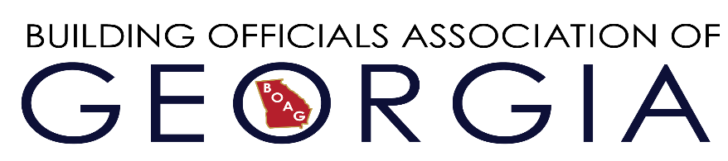
2021 BOAG Golf Tournament
Benefiting the BOAG Scholarship Fund
Date: Tuesday, May 18, 2021
Location: King and Prince Resort & Conference Center
Shotgun Start @ 1:00 PM

$100.00 a Person
$150.00 Golf Hole Sponsorships
$200.00 Sponsorship for Longest Drive and Closest to the Pin
Contests-Prizes-Gift Bags
You may register as a single player or partial/complete team.

Player E-Mail Contact Number

1-_______________________________________ ________________

2-_________ _______________________ _______________________

3-________________________ _________________________________

4-_______________________________________________________

Space is limited so please include a check made payable to BOAG with your registration and return before April 1, 2021.

Send To:
BOAG
PO Box 697
Snellville, GA 30078

